ASSIGNMENT -7

**QUESTION 1. Using Insert Function, give examples of any function available in the**

**different dropdowns present in the function library. For example**

**AutoSum, Recently Used, Text, Date & Time, etc.**

**Answer =**

**STEP 1.**

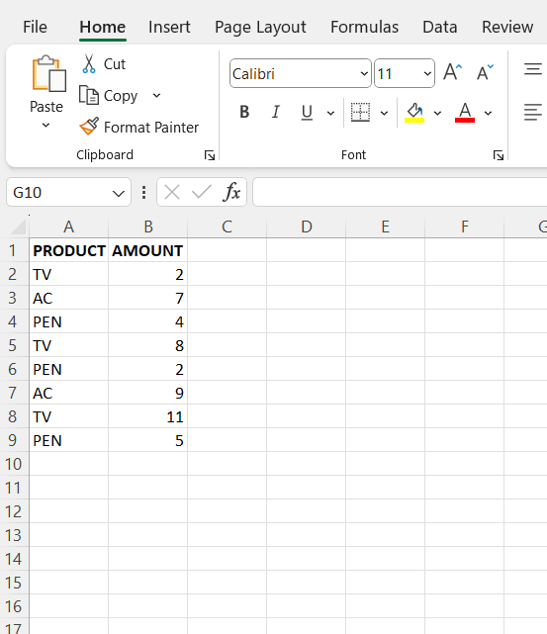

**STEP 2.** First ,Copy name column to another columnD and remove duplicates from column D .

To remove duplicates first go to DATA tab then click on remove duplicates under Data tools.

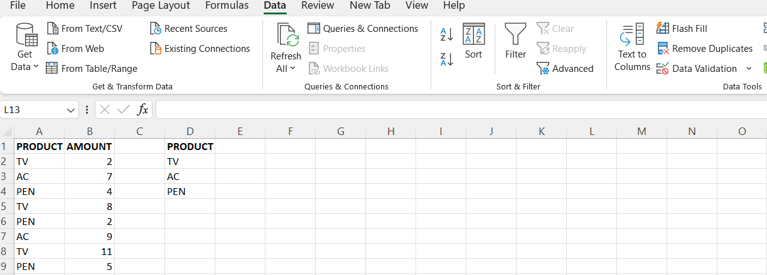

**STEP 3**

Add two new column , type **SELECT NAME** in cell **E1** and then type **TOTAL AMOUNT** in cell **F1.**

Then click **DATA tabe** to **DATA VALIDATION** under  **DATA TOOOLS GROUP .**

**STEP 4**

Select on cell E2 then click DATA to DATA VALIDATION under DATA TOOLS

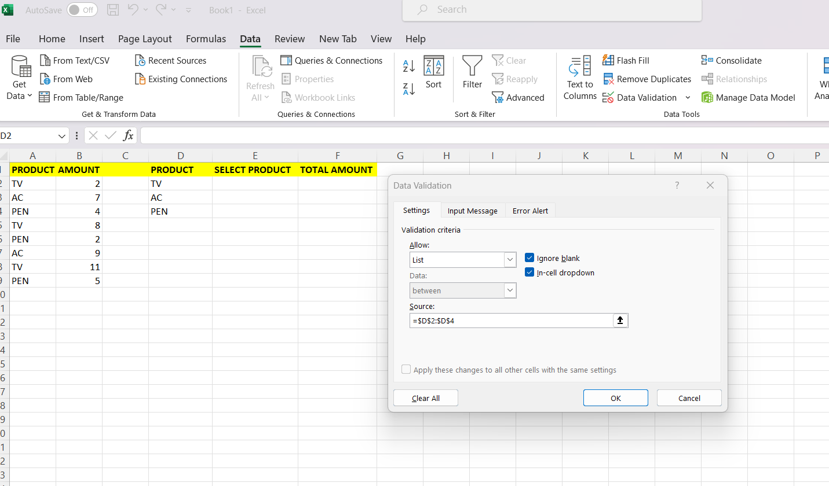

**STEP 5**

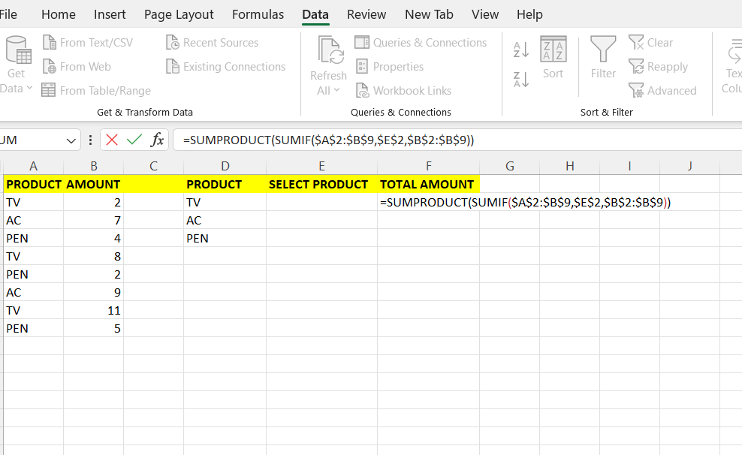

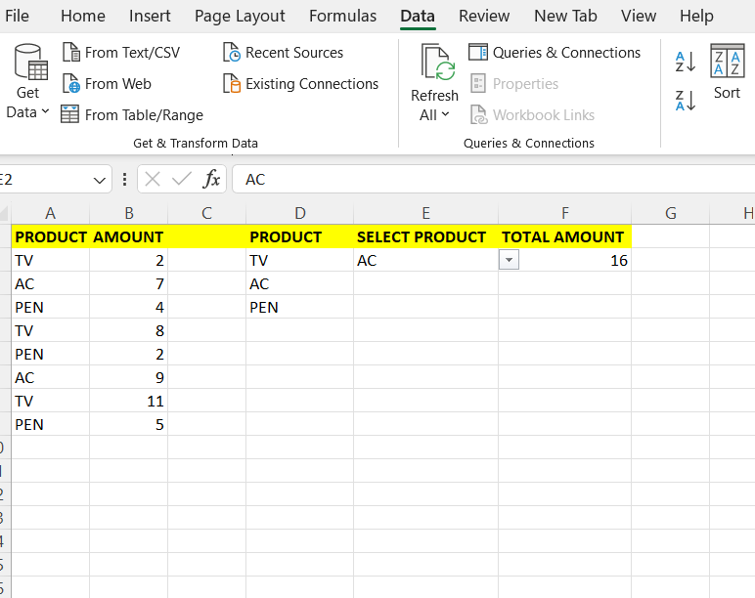

**DROP DOWN FOR TEXT**

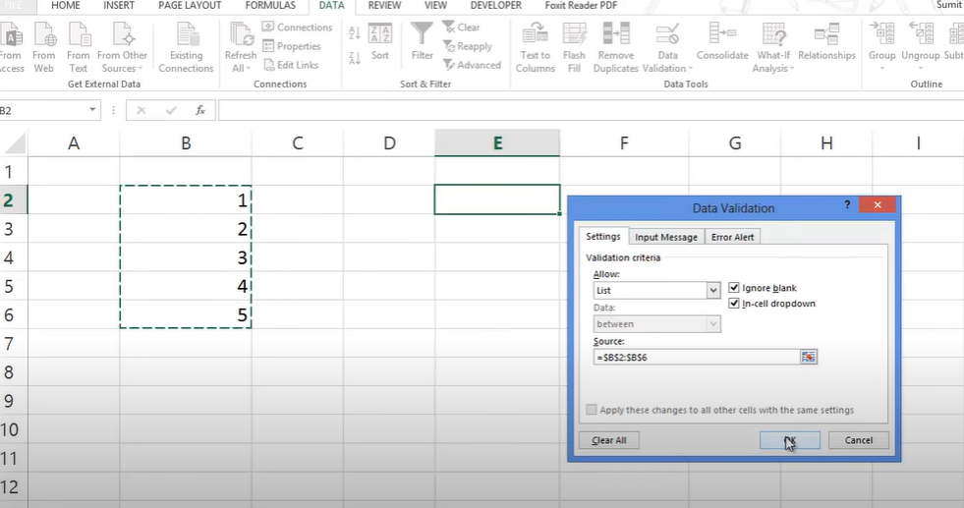

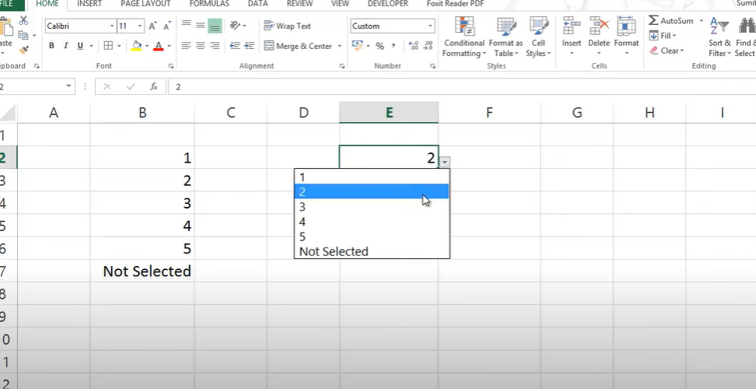

**DROP DOWN FOR DATE**

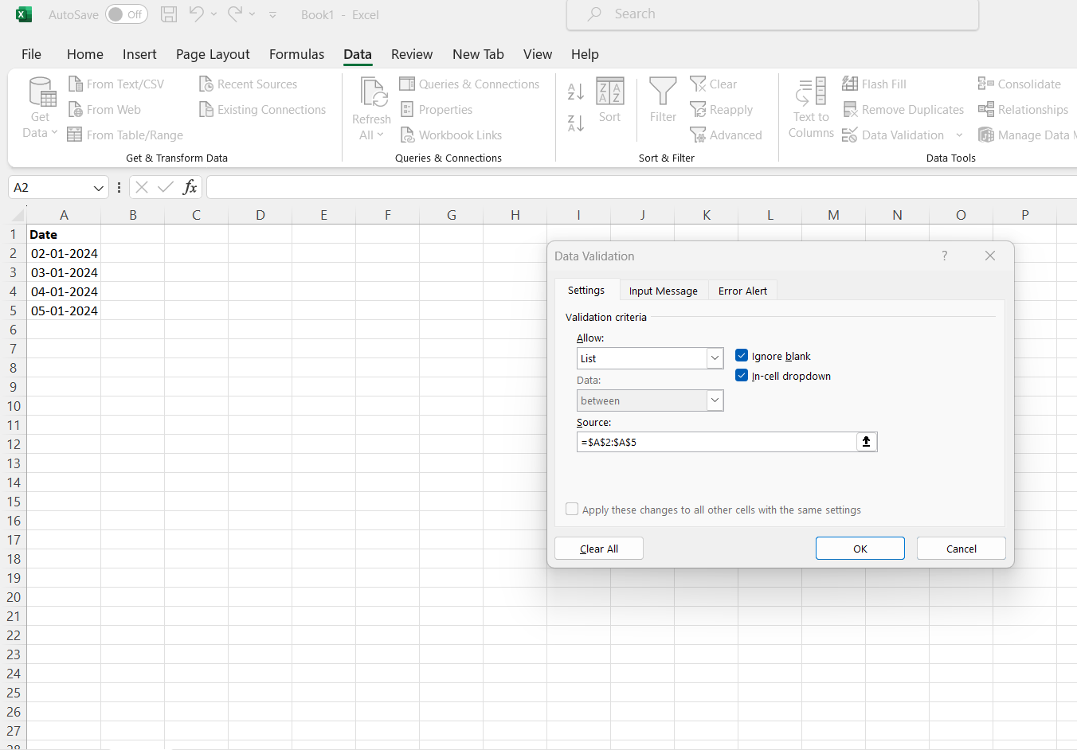

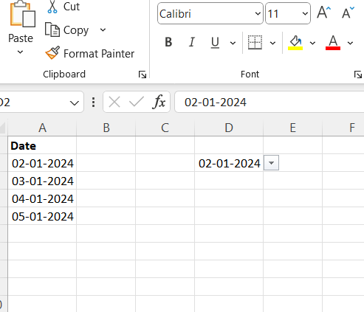

**QUESTION 2. What are the different ways you can select columns and rows?**

**Answer=**

**Selecting Columns:**

1. **Click and Drag:**
   * Click on the column header letter (e.g., "A" for column A) and drag your mouse to select multiple columns.
2. **Ctrl + Space:**
   * Place the active cell in the desired column and press Ctrl + Space to select the entire column.
3. **Shift + Arrow Keys:**
   * Select a cell in the column and use Shift + Right/Left Arrow to extend the selection to adjacent columns**.**

**Selecting Rows:**

1. **Click and Drag:**
   * Click on the row number (e.g., "1" for row 1) and drag your mouse to select multiple rows**.**
2. **Shift + Space:**
   * Place the active cell in the desired row and press Shift + Space to select the entire row.
3. **Shift + Arrow Keys:**
   * Select a cell in the row and use Shift + Down/Up Arrow to extend the selection to adjacent rows.

**Selecting Multiple Columns and Rows:**

1. **Ctrl + Click:**
   * Hold down the Ctrl key and click on multiple column letters or row numbers to select non-contiguous columns or rows.
2. **Ctrl + Shift + Arrow Keys:**
   * Select a cell and use Ctrl + Shift + Right/Left/Down/Up Arrow to extend the selection to multiple columns or rows.

**QUESTION 3. What is AutoFit and why do we use it?**

**ANSWER=**

In Microsoft Excel, AutoFit is a feature that allows you to automatically adjust the width or height of cells, columns, or rows to accommodate the content within them. This feature is useful when working with spreadsheet data to ensure that the entire content is visible without any text being cut off or unnecessary empty space.

**Here's how AutoFit works in Excel:**

1. **AutoFit Columns:**
   * To AutoFit the width of a column, you can double-click on the right boundary of the column header (the line separating the column headers).
   * Alternatively, you can right-click on the selected column, choose "Column Width" from the context menu, and then select "AutoFit Column Width."

AutoFitting columns is beneficial when you have variable-length content in different columns, and you want to ensure that all content is visible without unnecessary horizontal scrolling**.**

1. **AutoFit Rows:**
   * To AutoFit the height of a row, you can double-click on the bottom boundary of the row header (the line separating the row numbers).
   * Alternatively, you can right-click on the selected row, choose "Row Height" from the context menu, and then select "AutoFit Row Height."

AutoFitting rows is helpful when dealing with variable-height content within cells, such as wrapped text or different font sizes. It ensures that all content is visible without unnecessary vertical scrolling.

**Why use AutoFit in Excel:**

* Improved Visibility: AutoFit ensures that all content within a cell is visible, preventing text from being cut off or hidden.
* Enhanced Readability: It helps create a more readable and aesthetically pleasing spreadsheet by optimizing the size of cells, columns, and rows.
* Efficiency: AutoFit is a quick and easy way to adjust the layout of your spreadsheet without manually adjusting column widths or row heights.

In summary, AutoFit in Excel is a convenient feature for dynamically adjusting the size of cells, columns, or rows based on the content they contain, improving the readability and overall appearance of your spreadsheet.

**QUESTION 4. How can you insert new rows and columns into the existing table?**

**ANSWER=**

You can use the Insert commands in the Layout tab to manage the rows and columns in tables.

Top of Form

**Adding a row**

**STEP 1 . CREATE TABLE**

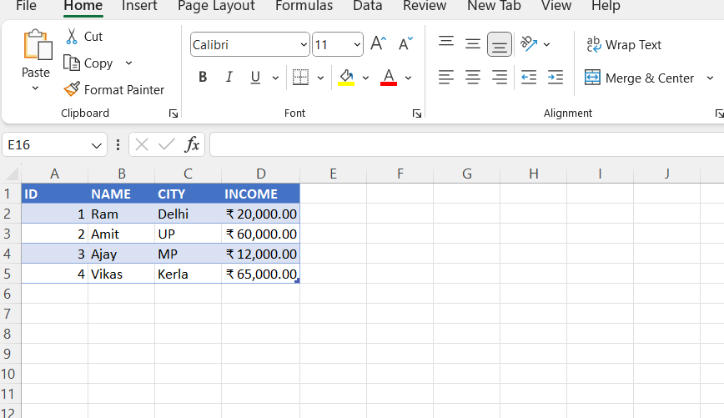

**STEP 2.** SELECT **COLUMN B** THEN CLICK **INSERT** THEN CLICK **INSERT CELL**

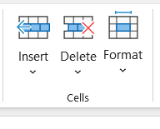

**ACCEPTED RESULT**

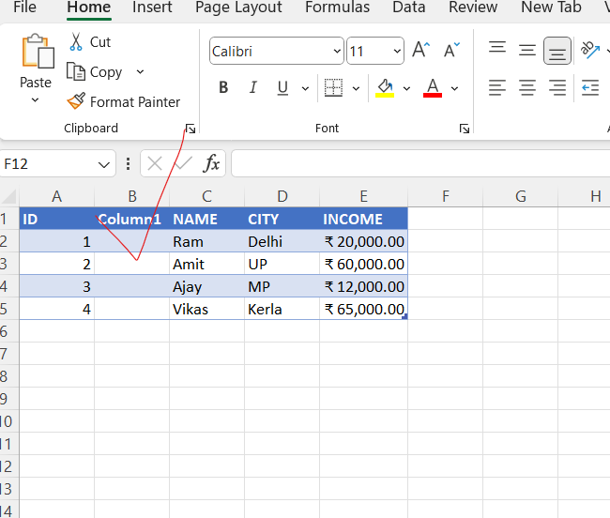

**SECOND METHOD TO ADD COLUMN**

*SELECT COLUMN YOU WANT THEN RIGHT CLICK AND CLICK ON INSERT*

**ADDING ROWS IN TABLE**

THIS TIME SELECT ROW AS PER REQUIREMENT THEN CLICK ON THE INSERT UNDER SELL THEN CLICK INSERT CELL

**QUESTION 5. How do you hide and unhide columns in excel?**

**ANSWER =**

Select as many columns as you want to select .

Suppose for this table which is given in the image I select column C

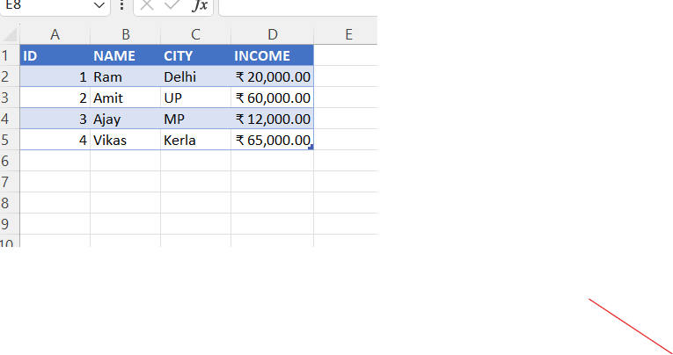

After that I right click on letter C then we will get hide option .

Accepted resule is

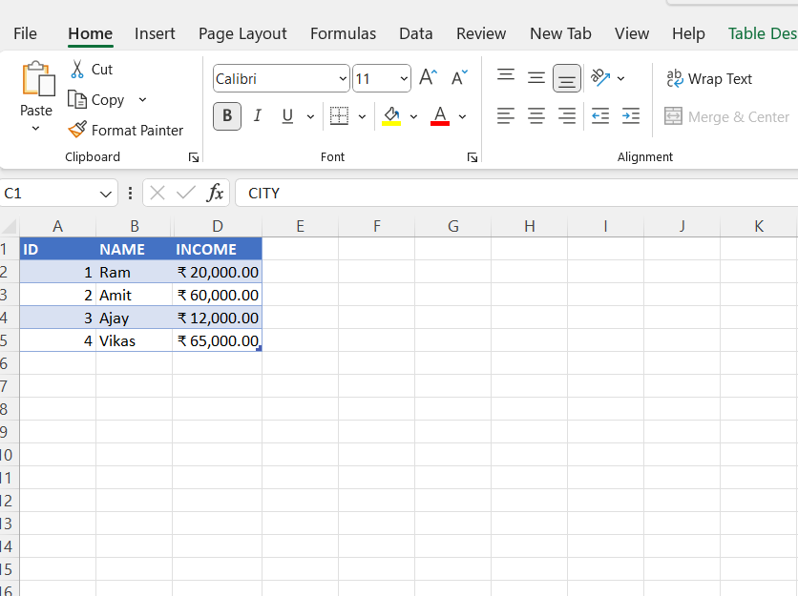

**QUESTION 6. Create an appropriate table within the worksheet and use different functions available in the AutoSum command.**

**ANSWER=**

**1. How to use SUM()**

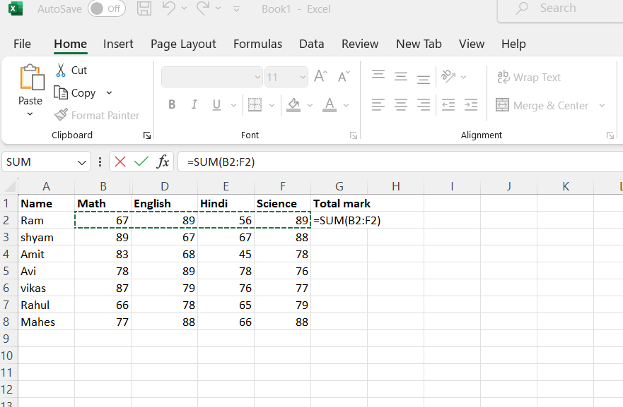

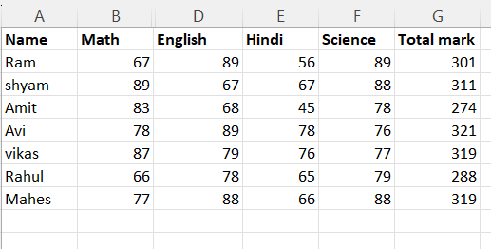

1. **How to use Average**

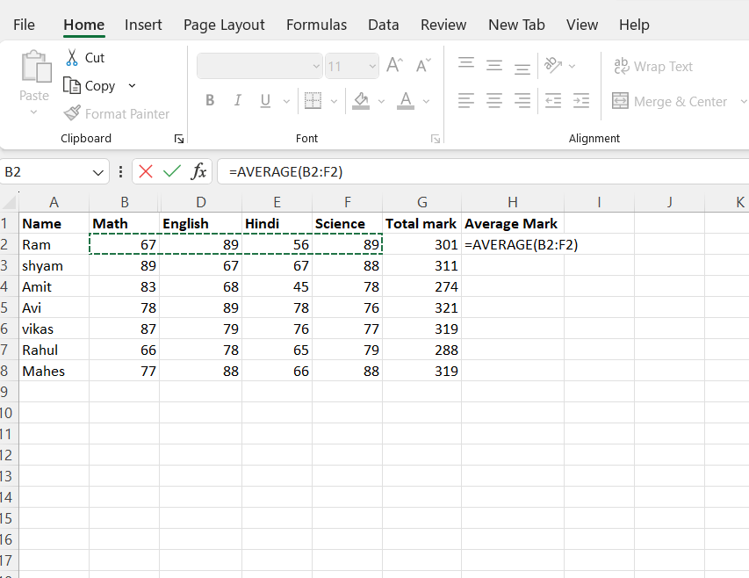

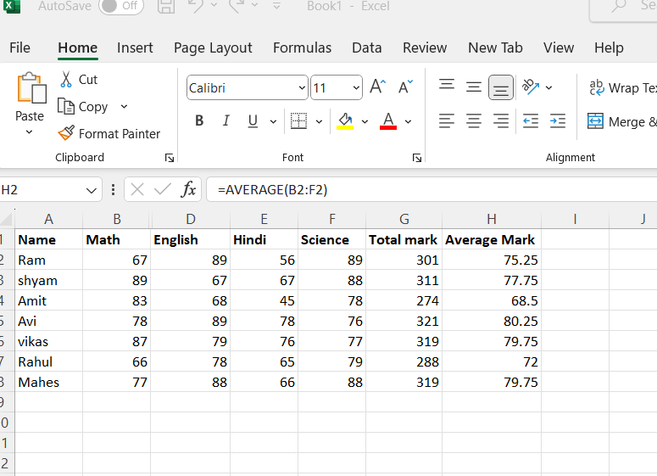

**3.Using max**

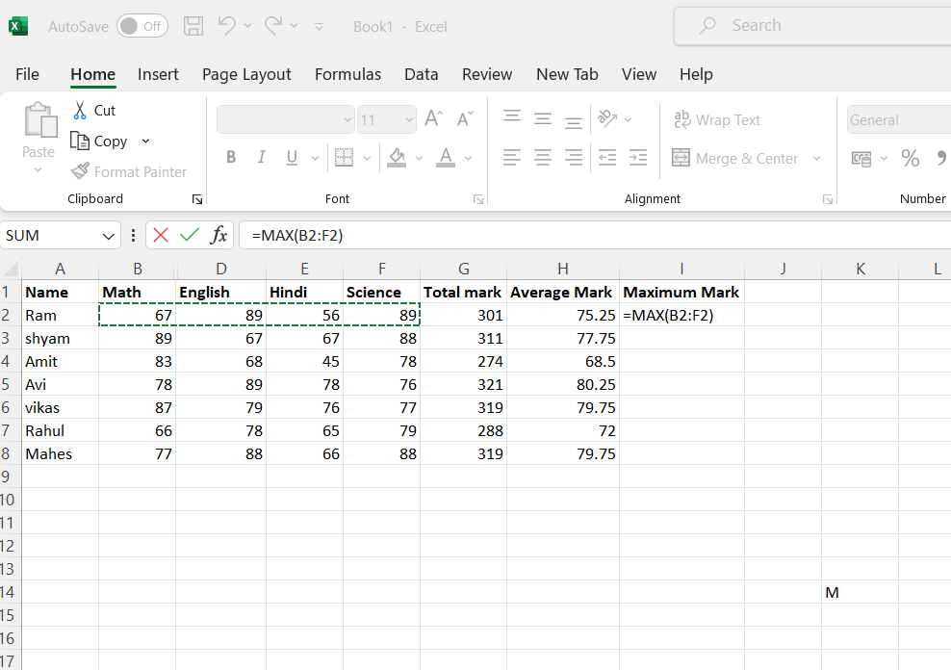

1. **Using MIN**

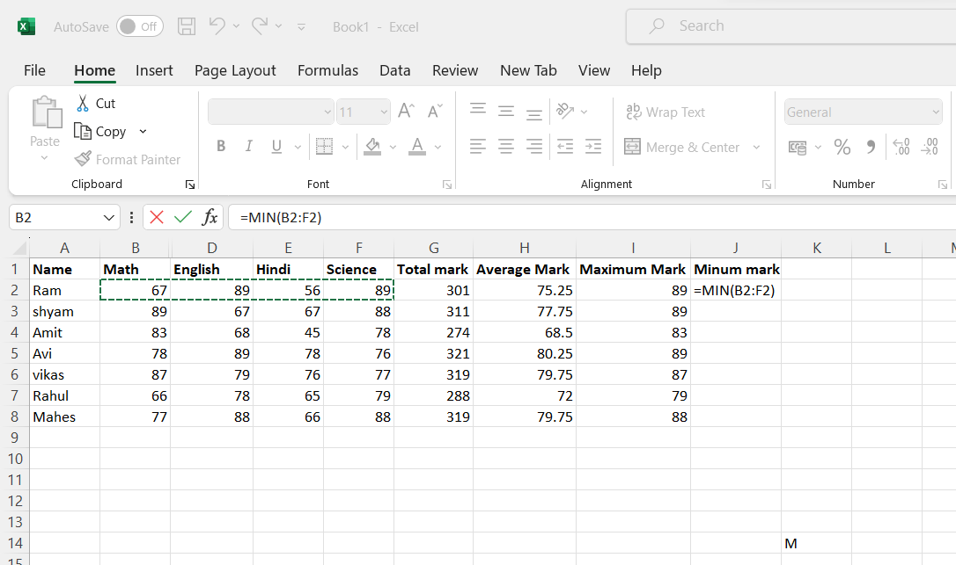

1. **Using count**

